Daniel Preller
13 May 2026
Assignment 9
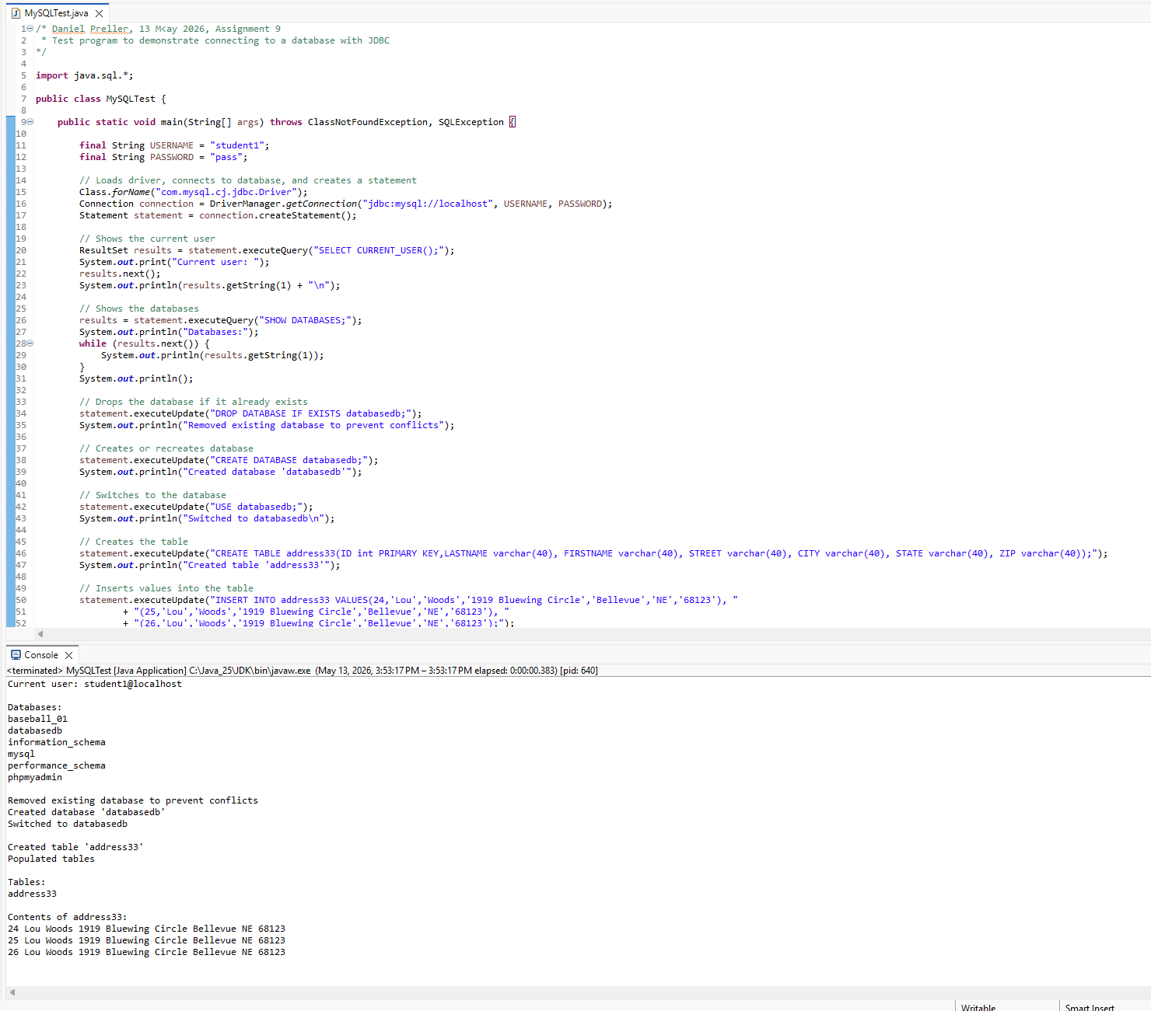
The MySQL server used was initially installed for CSD 440, hence the baseball_01 database.
GitHub Link: https://github.com/689Daniel/csd-420

